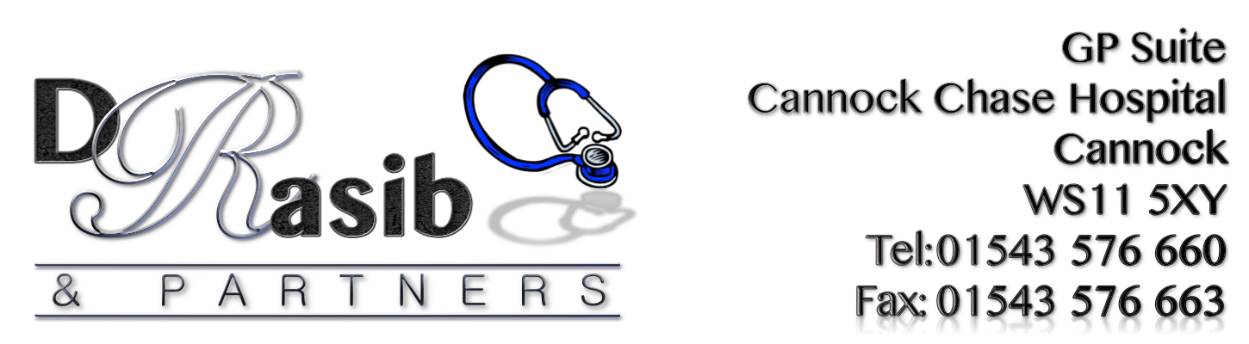
P.P.G. MEETING

Date: Wednesday 7th June 2017
@ 1.00pm
Location: GP Suite Cannock Chase Hospital.

Minutes

1) Persons Present: | Sam Rasib. David Stagg. Sarah Giles. Susan Andrews. Geoff Hackett. Janice Lloyd. Pam Burlingham. Val Cox.
2) Apologies: | Linda Mair. Jean Mabley. Betty Chapman.
3. Minutes of previous meeting held 9th March 2017: | Minutes from last meeting passed and agreed.
4. Matters Arising: | Welcome:  David welcomed everybody and opened the meeting by passing a blank Agenda round to all members. He then passed everyone a completed agenda – the point of this action was to remind everyone that they could put forward matters to be discussed and that it doesn’t all have to come from David. It was agreed that we should all consider items to be discussed at future meetings and pass them to David for him to put on the Agenda. He would appreciate some help due to his personal circumstances, if we want him to continue as chairman.  David also requested that all members ensure he has up to date contact details so that he can ensure his list is accurate.
5. Managers Report: | Sam distributed the newsletter for everyone to look at. The changes in DNA numbers were discussed. The practice list size is now 5581, down 33 from March 2017. It was decided that printing the Newsletter twice per annum is not enough as too much information for 2 issues. It was decided to print quarterly as shown below:  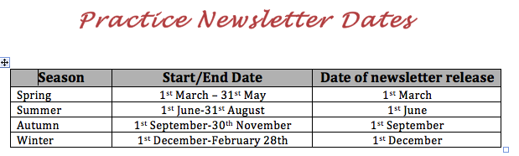  Rosie has kindly offered to help with the production of any future newsletters. Sam requested input for future editions. If anyone has ideas or information applicable to pass it to her ready for next launch on 1st September.
6. Patient Questionnaire handover | Annual Survey:  Results and action plan for annual survey conducted was discussed. Please see action plan attached to the end of the minutes. A copy of the survey results can be found both in the PPG folder in the waiting room and also on the practice website.  Practice Improvement Survey:  Sam also discussed the results of a further practice improvement survey which was conducted during the month of May 2017, again the results of this survey can be found on the practice website and also in the summer edition of the newsletter.  The main changes being made from the suggestions made from the latter survey were:  - The introduction of pre-bookable appointments as 100% of patients requested this and  - Also for the practice to introduce a Facebook page so they are kept updated with news and information about the practice. This has now been launched.  Pre-bookable appointments:  It was suggested that we try to save 16 appointments for same day and release 20 as pre-bookable appointments. Sam will set this accordingly and will monitor closely ensuring that DNA figures do not increase. If they do then things will need to be reviewed.  Buddy Scheme:  The buddy scheme needs to be advertised more. Sam said that ideally to set a target of aiming for at least 10 more buddies to be on the register by the end of the year.  Dementia Chat Clinics:  Dementia chat clinic needs to be advertised more. Sam said she has added this to waiting room screen, letters have been sent to patients, flyers are in production, details have been added to newsletter, website and now Facebook page too.  Action Plan:  Patient buddy and Patient Access are two main items to be focused on in action plan.  Everyone agreed with the action plan.  Janice suggested information being put on waiting room screen.
8. A.I.R. Any information to report: | Dementia Awareness Session:  Sam stated that a “pop in” Dementia awareness session will take place on Friday 23rd June at 12pm.  PPG members meeting with Dementia Patient Manager:  Sam will arrange a meeting with Jenny Ashley (Dementia Patient Manager) – possibly 3rd July 1.30 – 2.00 pm for all PPG members to meet her and get a better understanding of what she is able to offer.
9. Chairman, group items: | There is to be a large CCQ-PPG meeting, but not practice specific. David asked if anyone would like to participate.  David has been keeping a list of Group achievements since the group was formed and he stated he was happy to continue doing this.  David has a list of “posts” that require people to volunteer.  1) Janice & Pam offered to look after the notice board.  2) Sarah agreed to continue with virtual items. 3) Sue offered to be Agenda secretary.  4) Val agreed to continue doing the minutes.  If anyone else would be able to help, please contact David and he will let you know what jobs are still available.  All jobs need to be allocated so that all members have a role that they are responsible for so please speak to David.
11. Any Other Business: | The cake sale for the practice in aid of CANCER RESEARCH took place on Tuesday 6th outside the practice entrance and was very well supported. Val managed the stall all day helped by Susan in the morning and Sarah in the afternoon, with David covering a side table with samples of cake baked by staff. Voting took place anonymously for best bake by staff members. After the sale, the winner was announced and presented with “Best Baker Award”. Hannah was our winner. At the end of the day we had raised over £250 and Sam had started a Just Giving page on the practice website. The participation was amazing from everyone. A very big Thank you to all who baked and helped out. Your efforts were very much appreciated.

Date of Next Meeting: Wednesday 9th August @1pm

ACTION PLAN

Problems Identified | Action | Who is involved? | Timescales
Preference for booking appointments via phone | The Practice recognizes that telephone contact is the preferred method of communication for patients with regards to contacting the surgery. However, this is adding to the level of telephone congestion that is being experienced by patients and therefore would like to encourage patients to book appointments using alternative methods that are available (patient access) which are just as convenient and result in the same outcome. The practice are therefore intending to advertise online communication method more by advertising it on TV screen in waiting area, through leaflets that will be available for patients in the waiting area and also on the website. We are also offering patient access training sessions for those patients who may need help with using this method and PPG members have offered to help with raising awareness about Patient Access too. Sarah will be doing a display about patient access for the notice board situated in the waiting area and has offered to help with the training too. Sarah has seen the benefit of using patient access so is happy to share her experience with other patients. | GP Partner  Managing Partner  Sarah Giles (PPG)  PPG members  All practice staff | On-going throughout the year
Telephone Access – Getting through to the surgery via telephone has been identified as a major issue | The Practice will continue to source external quotes from telephony companies and also liaise with the Health Informatics/Telephony department within the hospital to see if there are alternate solutions on the current systems. We would however like to encourage patients to use online communication where possible to try and help the practice to improve in this area. | GP Partner  Managing Partner  Sarah Giles (PPG)  PPG members  All practice staff | On-going throughout the year
Lack of awareness about the Practice’s complaint procedure | Further leaflets shall be produced for patients to have access to. The complaints procedure will be advertised further within the waiting area. Details shall also be added to the Practice leaflet and the practice website will be reviewed to try and make the procedure more obvious to patients | Practice Manager | June 2017
Suggestions made on improving surgery | A lot of the suggestions created a common theme and these were ‘More GP appointments’ and ‘Telephone access’ … This has been discussed with the PPG members (9th March 17) and the practice has asked the members to help the practice to find solutions in trying to improve in these 2 areas. Since last year the practice has introduced a further phone line at 8am and another for the whole day, it has been reiterated to all reception staff that all calls MUST be answered within 3 rings, patients are not to be put on hold under any circumstances and a back-up phone has been added for all unanswered calls to be diverted to should the main lines not be answered for whatever reason. The Practice manager holds the backup phone and it has been monitored since being introduced and she can confirm that not many calls have come through to her.  The Practice has been in talks with the hospital and external telephony services to try and come up with solutions but unfortunately so far this has proven to be unsuccessful.  The practice is therefore turning to other solutions and this time it involves encouraging patients to use online communication via patient access.  With regards to lack of appointments, the practice has taken on a Pharmacist Practitioner; he is able to deal with most conditions so again patients are being urged to book with him where possible so this allows the GP to deal with the more complex cases.  The Plan therefore is to raise patient awareness in relation to these 2 areas. | GP Partner  Managing Partner  Sarah Giles (PPG)  PPG members  All practice staff | On-going throughout the year
Patient Buddy Scheme | Aim to advertise this more in the waiting area and PPG members to be involved in this process. Coffee mornings to be arranged to help with advertising both ‘Patient Access’ and ‘Patient Buddy Scheme’.  Our aim will be to get at least 20 patients on the Buddy register in the next 12 months and at least another 5% of patients to be signed up for patient access. | GP Partner  Managing Partner  Sarah Giles (PPG)  PPG members  All practice staff | On-going throughout the year
Becoming a Patient Buddy | The practice and PPG members will continue to raise awareness about this scheme with the aim to get at least 20 buddies in the next 12 months. | GP Partner  Managing Partner  Sarah Giles (PPG)  PPG members  All practice staff | On-going throughout the year

